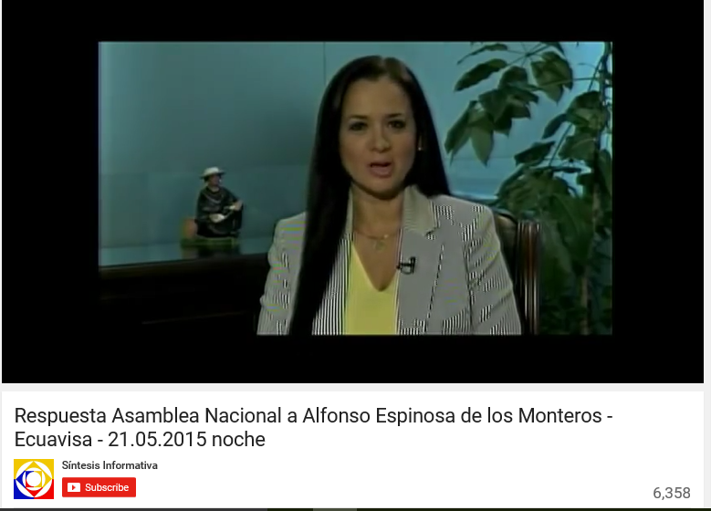
https://www.youtube.com/watch?v=Ky6kK3p8zzs

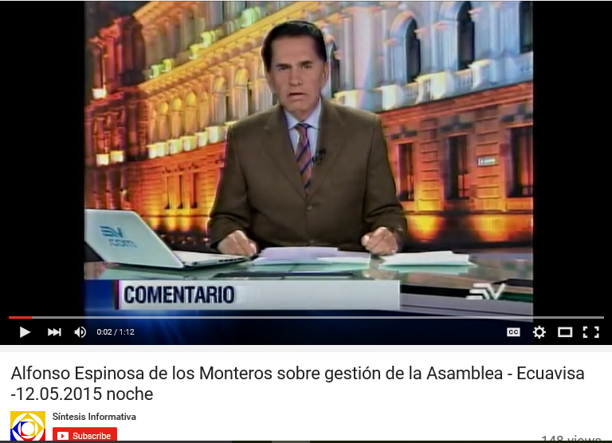
https://www.youtube.com/watch?v=oTquWHsZ5yU

